BUTANE

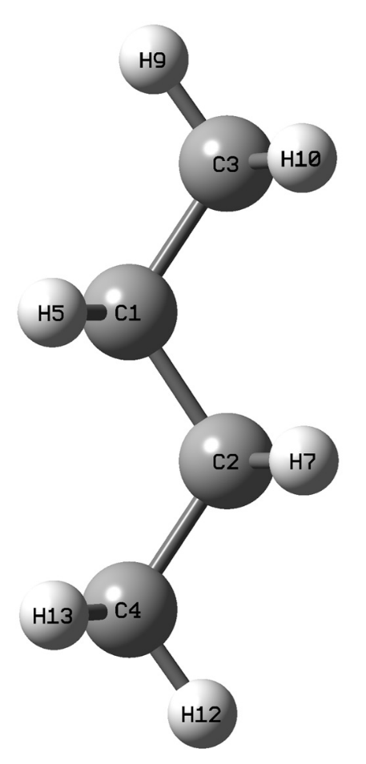

LUMO= 0.09672

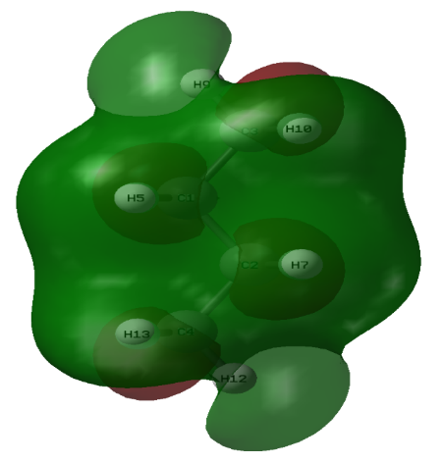

Eg= 10.9574ev

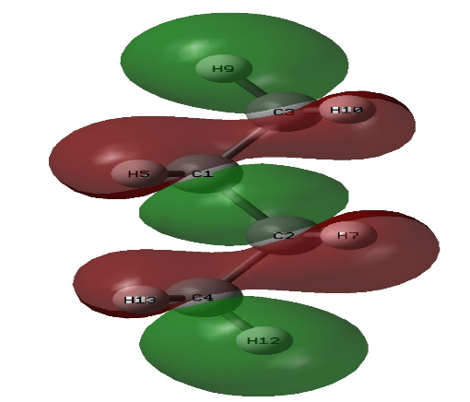Homo= -0.30596

The energy difference between the HOMO and LUMO is known as the HOMO-LUMO gap.

The HOMO-LUMO energy gap of butane is approximately 9.5 eV. By b3lyp/6-31G energy gap is about 10.9574ev .This gap is relatively large, indicating that butane is a stable molecule with low reactivity. HOMO and LUMO: In the context of molecular orbitals, the Highest Occupied Molecular Orbital (HOMO) represents the energy level of the outermost electrons, while the Lowest Unoccupied Molecular Orbital (LUMO) represents the energy level of the next available orbital. This gap is a crucial parameter in determining a molecule's chemical reactivity and stability. For butane, the HOMO-LUMO gap is calculated to be around 9.5 eV, according to some sources. This large gap signifies that it requires a significant amount of energy to promote an electron from the HOMO to the LUMO, making butane relatively stable and unreactive. A large HOMO-LUMO gap implies that the molecule is less likely to participate in chemical reactions, as it requires more energy to initiate electron transfer or excitation. Conversely, a small HOMO-LUMO gap suggests higher reactivity and potentially lower stability.

**Electrostatic Potential (ESP) of butane**

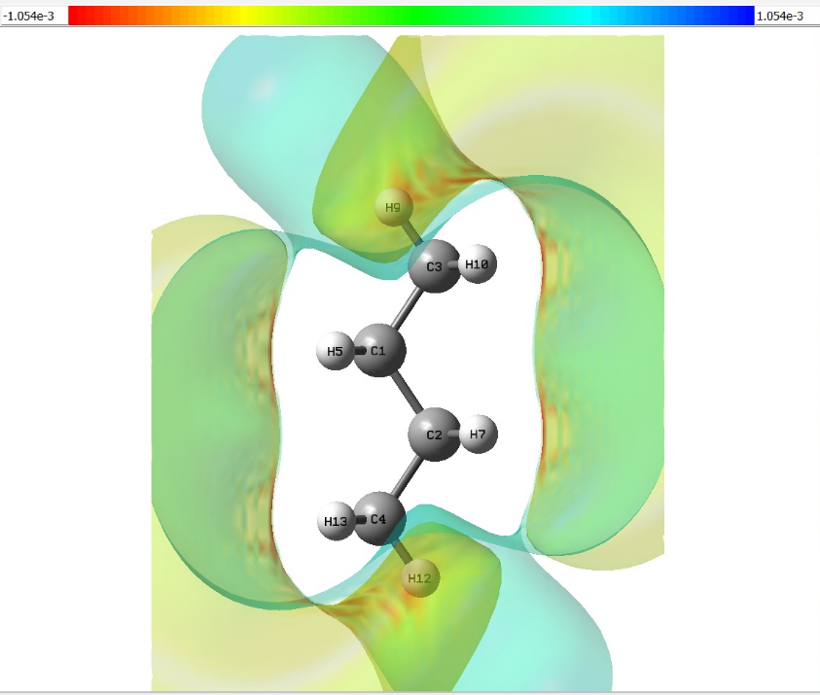

**ESP of Butane – Quick Summary**

* **Butane (C₄H₁₀)** is a non-polar, saturated hydrocarbon with a linear alkane structure.
* Its **ESP map** shows a relatively **uniform electron distribution**, with:
  + **Low polarity** across the molecule
  + **Slightly negative regions** near carbon atoms due to higher electronegativity
  + **Slightly positive regions** around hydrogen atoms
* There are **no strong dipoles or reactive sites**, making butane chemically inert under normal conditions.
* ESP values typically range in the **±10⁻³ a.u.** scale, as seen in your image — indicating subtle charge variations but no significant electrostatic hotspots.
* In **docking or interaction studies**, butane serves as a **hydrophobic probe** or control molecule.
* Its ESP map helps benchmark **non-polar reference surfaces** in comparative electrostatic analyses — useful when contrasting with plant-derived antioxidants or polar ligands.

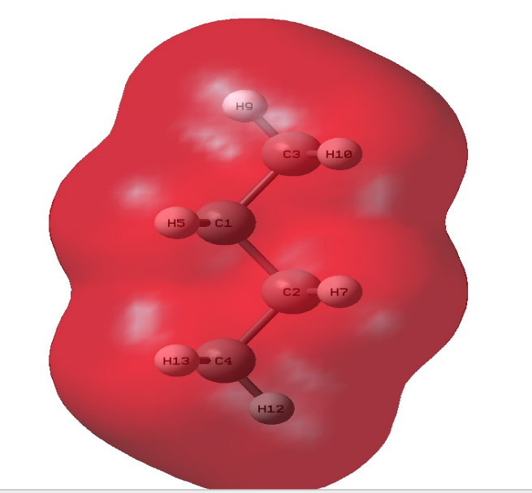

**What Is Electron Density?**

**Electron density**, denoted as **ρ(r)**, describes the **probability of finding an electron** at a specific point **r** in space around a molecule. It’s a fundamental quantum chemical property derived from the molecule’s wavefunction — and it governs nearly everything:

* **Bonding behavior**
* **Molecular shape**
* **Reactivity and polarity**
* **Electrostatic potential (ESP)** and **molecular orbitals**

According to the **Hohenberg–Kohn theorem**, the ground-state properties of a molecule are uniquely determined by its electron density — not the wavefunction itself. That’s why **Density Functional Theory (DFT)** is so widely used: it calculates energy and structure based on ρ(r).

**Visualized**

In your uploaded images, the **colored lobes** and **red shading** represent **isosurfaces** of electron density:

* **High density (red/blue lobes)**: near nuclei or bonding regions
* **Low density (transparent or outer regions)**: van der Waals surface or non-bonding zones

These maps help identify:

* **Bonding types** (σ vs. π)
* **Charge distribution**
* **Reactive sites** (nucleophilic/electrophilic zones)

**contour plots**

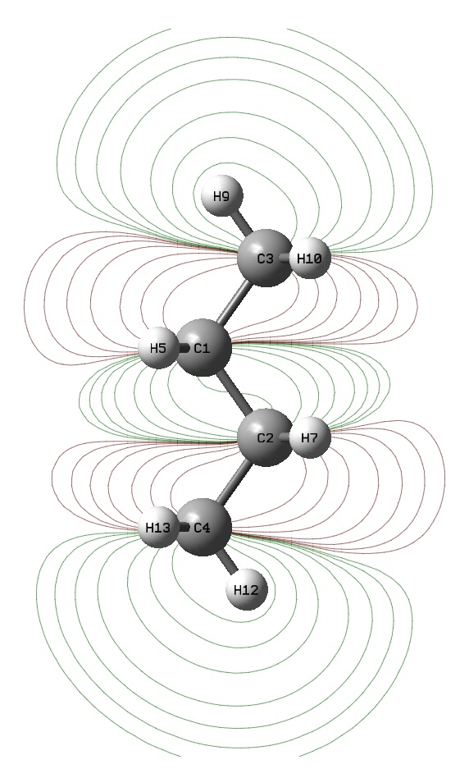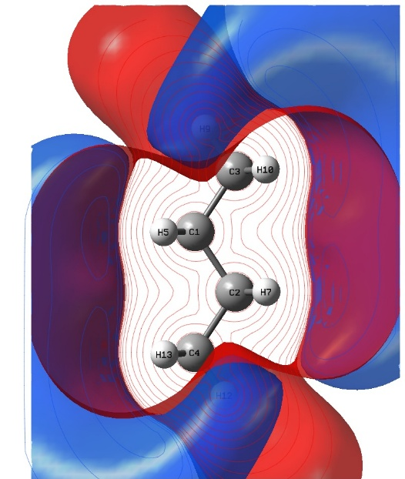

A **contour plot** is a 2D representation of a 3D scalar field — like **electron density (ρ)** or **electrostatic potential (ESP)** — where **lines connect points of equal value**. Think of it as a topographic map for molecules.

**In Molecular Modeling:**

* **Contours = isovalues** of a property (e.g., ρ(r), ESP, HOMO/LUMO)
* **Each line** represents a constant value (like ρ = 0.002 a.u.)
* **Spacing** between lines shows gradient intensity (closer = steeper change)

**Common Uses**

| **Property** | **Contour Purpose** | **Insight Gained** |
| --- | --- | --- |
| **Electron Density** | Visualize bonding regions and atomic shells | Identifies covalent vs. non-covalent zones |
| **ESP Maps** | Show charge distribution around molecule | Highlights nucleophilic/electrophilic sites |
| **Molecular Orbitals** | HOMO/LUMO shapes and nodes | Predicts reactivity and orbital overlap |

**🧰 Tools That Generate Contours**

* **Gaussian / ORCA / NWChem**: Output cube files for density or ESP
* **Multiwfn**: Extracts and plots contours from cube data
* **VMD / Chimera / PyMOL**: Visualize isosurfaces and contour slices
* **Avogadro**: Quick contour overlays for orbitals and ESP